
YEAR 12 UNIT 3 HUMAN BIOLOGY
TEST 1 ENDOCRINE and NERVOUS SYSTEM
ANSWER KEY
Section One: Multiple Choice (10 Marks)
Suggested working time: 10 minutes.

Select the best alternative from the answers given and mark your choice like this
(a) (b) (c) (d)

1. (a) (b) (c) (d)  2. (a) (b) (c) (d)  3. (a) (b) (c) (d)  4. (a) (b) (c) (d)  5. (a) (b) (c) (d) | 6. (a) (b) (c) (d)  7. (a) (b) (c) (d)  8. (a) (b) (c) (d)  9. (a) (b) (c) (d)  10. (a) (b) (c) (d)

Section Two: Short Answer (40 Marks)
Suggested working time: 40 minutes.

Question 1 (4 marks)

Hyperventilation can occur voluntarily or involuntarily. It can occur involuntarily in response to severe pain or extreme fear.

Complete the following table to distinguish between the two different efferent nervous divisions that can regulate hyperventilation.

 | Names of two different efferent nervous divisions
 | SOMATIC | AUTONOMIC
Neurotransmitters | Acetylcholine | Acetylcholine and noradrenaline
Effect of neurotransmitter on  effector(s) / target organ(s) | Excitory/ stimulatory | Excitory and inhibitory
The number of neurons  between the CNS and effector/target organ | One | Two
1 mark per row(4 marks)

Question 2 (18 marks)
Below is an action potential graph showing the outcome from two different stimuli on the same neuron. Look at the graph below and use it to answer the questions that follow.
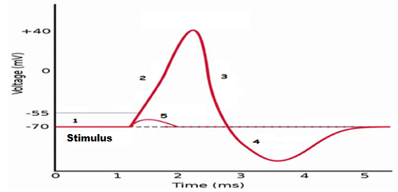

- The first stimulus resulted in the line labelled with the number 5. Describe what could have occurred here.
Stimulus not large enough to generate an impulse
(1 mark)
- The second stimulus resulted in the line labelled with the numbers 2, 3 and 4.
Describe TWO events that could not possibly occur during these phases.

Another impulse
Impulse go backwards
(2 marks)

- Looking at the action potential graph, locate the section labelled with a 1.
In the box below draw a labelled diagram of this section of the neuron to show:

- the concentration of the sodium and potassium ions and, if they are moving, the direction the ions would be travelling.

- the gated ion channels and whether they are open or closed.
- the charge either side of the neuron membrane.
(i) high Na outside, low inside so goes in, opposite for potassium (1) (must show Na and K on both sides of membrane, not just side in highest concentration for the mark)

- Sodium/Potassium pump moving Sodium out and Potassium in (1) (Sodium potassium pump must be labelled as such and showing direction of movement for mark)
(ii) Na and K gates closed (1)
(iii)Positive outside / negative inside (1) (Inside and outside of cell must be labelled on the diagram to be awarded this mark)

(4 marks)

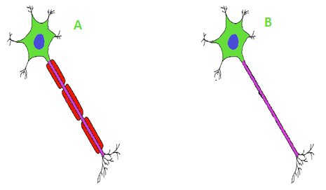
- Look at the diagram below of the different nerve fibres and answer the questions that follow.

State which nerve fibre shown above is myelinated and whether the myelinated part of the neuron would be found in grey or white matter.

Myelinated – A (1) Myelinated axon found in white matter (1)
(2 marks)

- Draw an annotated diagram below of a reflex arc ensuring you correctly identify each type of neuron involved
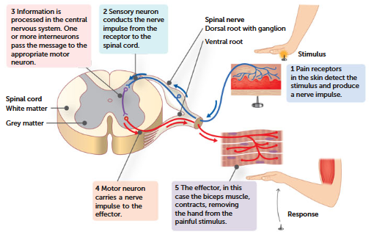
(1 for each numbered box – words do not need to be exact) (5 marks)

- When a nerve impulse reaches the end of the axon it has to cross the synaptic gap before it can reach the next dendrite and the impulse continue.
Discuss what occurs when a nerve impulse arrives at the pre-synaptic knob in order for it to cross the gap and continue along the next neuron.
- When sodium rushes in / or impulse arrives causes the calcium channels to open OR
- Calcium rushes in and causes the vesicles carry the neurotransmitter to fuse with synaptic knob membrane (1)

- Vesicle releases the neurotransmitter by exocytosis (1)
- Neurotransmitter diffuses across the gap (1)
- Neurotransmitter locks on to the receptor on the post synaptic knob (1)

(bottom three points must have correct terminology or no marks
and then one mark from 1st two)
(4 marks)
Question 3. (18 marks)

- The pituitary gland is sometimes referred to as the “master gland”, however, it could be argued the hypothalamus should have this title. Describe how the hypothalamus controls the secretion of hormones from the anterior and posterior lobe of the pituitary gland.

- Anterior lobe controlled by releasing and inhibiting factors (1 mark) from the
hypothalamus (1 mark) that reach the anterior lobe via network of
blood vessels/hypophyseal portal (1 mark).
- Hormones (oxytocin and ADH) are produced in the hypothalamus (1 mark) and passed along nerve fibres/axon to the posterior lobe, to be stored/secreted (1 mark) secretion initiated by nerve impulse from hypothalamus (1)
(6 marks)

- The pituitary gland releases a variety of hormones into the blood stream. Two hormones made by the pituitary are stated in the table below. Complete the table in relation to each of these hormones.

Hormone | Target cells/Organs | Function/s or Effects
FSH | Ovaries & Testes  (both needed for the mark) | Growth follicles / sperm production  (both needed for the mark)
ACTH | Adrenal Cortex  (not adrenal glands) | Production of cortisol / hormones of adrenal cortex  (1 mark per box)
(4 marks)

- On the outline diagram below, draw an annotated diagram of the mode of action of a water soluble hormone

Shows
hormone diffusing out of capillary (1)
Hormone-receptor complex (1)
Secondary messenger (1)

(3 marks)
- Insulin is a protein based hormone whereas cortisol is a steroid based hormone. Explain briefly the differences in the ways the two types of hormones bring about a response in the cell.
Lipid/ Steroid – in nucleus affects transcription/ activates genes
Water soluble – secondary messenger activates particular enzymes
(2 marks)
- Both the nervous system and endocrine system communicate within the body but do so in differing ways that complement each other. Compare three differences in the way the nervous system and endocrine system communicate.

Nervous system | Endocrine system
Type - Electrical impulses/neurotransmitters | Type - Hormones
Transported - Along membrane of neurons | Transported - In the bloodstream
Affects muscle and gland cells, other neurons | Affects all body cells
Response-local and specific | Response-general and widespread
Fast acting – within milliseconds | Slower – from seconds to days
Short duration, brief, stops quickly when stimulus stops | Longer lasting, may continue long after stimulus has stopped
Any three comparisons
(3 marks)
Section Three: Extended answer (8 Marks)
Suggested working time: 10 minutes.
Bill is in a panic; he is late for his bus. He can see it clearly in the distance and he is sprinting to get there. He needs lots of oxygen, he needs lots of glucose and he needs it now
Identify which part of the nervous system would be activated and explain how it prioritises the energy Bill needs for his fast working muscles.

Running fast to catch the bus requires Bill to engage his sympathetic nervous system (1) as he is very much in a flight or fight (1) scenario, running for the bus. Sympathetic nerves encourage these parts of the body to respond appropriately to the scene.

1 mark for listing the affected structure | 1 mark for explaining how this structure of the body increases cellular respiration
bronchioles of the lungs dilate | allowing more oxygen in
adrenaline targets the liver to accelerate the breakdown of glycogen to glucose | provides greater amounts of glucose to the working skeletal muscles
skeletal muscle blood vessels vasodilate | pushes lots of oxygen and glucose to the working skeletal muscles to provide them with energy
noradrenaline causes the heart to contract more strongly and frequently | pushes the blood [glucose and oxygen] more rapidly around the body to the muscles
blood vessels to internal organs and the skin, vasoconstrict | prioritizes where the oxygen and glucose to working skeletal muscles go as this is not needed as much for the internal organs and the skin of the body

3 marks 3 marks [8 marks overall]
END OF TEST

